Benton Franklin Workforce Development Council
Executive Committee Minutes
January 26, 2021
3:15 p.m.
Zoom

Staff Tiffany Scott Jan Warren
Present
Commissioner McKay Todd Samuel
Melanie Olson Adolfo de Leon Amand Jones
ExcusedAbsent
Dennis WilliamsonCommissioner Dider

Ste
David Chavey- Reynaud
Diana Hamilton Cynthia Garcia Jamilet Nerell Jessie Cardwell Becky Smith
Guests
Amand Fisher, LNI Crystal Bright, WSO

Call to Order - Todd
Todd Samuel called the meeting to order at 3:15 p.m. and thanked everyone for attending. Becky read through the roll call. Todd welcomed Benton County Commissioner McKay to his first meeting.

Minutes – Todd
Minutes from November 24, 2020, Executive Committee Meetings were provided to members for review.

Amanda Jones moved to approve November 24, 2020, Executive Committee Meeting Minutes as presented, seconded by Adolfo de Leon. Motion carried.

Finance Reports – Jan
Jan provided the printed Finance Reports through November 2020
- Corporate Entity: Jan reported that there had not been much change to the Corporate Entity Account. The Certificate of Deposit (CD) will be maturing next month, and we will be looking into options to renew. Interest rates are pretty low at this time.
- Main BFWDC Account: There is a negative balance in the Cash Line as expected while waiting for the A19s to be reported in the following month. We are operating on bare-bones, rent, and salaries as were predicted. Travel and supplies are low due to cancellations and staff not working in the office. Overall, things are where we expect them.
- WorkSource: This is a snapshot of where WorkSource Columbia Basin (WSCB) was at at the end of November. It reflects the slow activity. We are paying the basics, rent, and facilities. Supplies and Dues/Fees will run under budget until the facility is open.

PY19 Rapid Response Increase Employment (RRIE) Contract Modification – Diana
Diana presented a memo stating that the BFWDC has identified $11,000 of PY19 RRIE funds within our budget that we will be unable to spend before June 30, 2021. In reviewing the December 2020 RRIE invoices, our service provider, Career Path Services, has expended 98% of their Individual Training Account (ITA) budget. BFWDC staff recommends the PY19 RRIE contract modification of $11,000 to Career Path services to increase the contract amount from $248,679 to $259,679 to increase the number of dislocated workers who receive training opportunities and obtain employment.

Todd Samuel moved to approve the modification of the PY19 Rapid Response Increase Employment Contract from $248,679 to $259,679 to increase the number of dislocated workers who received training opportunities and obtain employment, seconded by Melanie Olson. Motion carried.

Liaison Report – David
David shared the December Liaison Report. In December 2021, we had 412 job seekers, 36% of what we saw in December of last year, and 765 staff-assisted services to job seekers at 29% of what we saw last

year. The unique number of businesses served is 98%, and staff provided business services is 139% of December of last year. Our business outreach during the pandemic has been incredibly strong. We continue to work on outreach and new methods to get the word out to our job seekers that we are here to help. He continued to review numbers off of the Liaison Report.

Amanda Jones thanked David for providing last year’s numbers for comparison. She requested having the previous year’s report included in the packet for comparison.

David shared that services are still being offered at WSCB but that people are being served virtually. We are working on outreach efforts for those that need assistance. They continue trying to address meeting the needs of those that would typically be walking through the doors. Crystal shared that efforts are occurring to reach out to customers and engage them. We see some influences at play regarding safety and whether or not people are seeking jobs, the Unemployment Insurance (UI) job search waiver, child care, etc. We are working to be adaptable and approachable and looking through new eyes to engage customers in new ways.

Tiffany brought up two points. What is the most significant fire that we need to address? Getting UI to people has been a priority. The Employment Security Department (ESD) shifted seven employees to UI, and they will be pivoting back soon. We also encouraged more staff to be dedicated to business services.

David shared that they will be meeting with the Operator next week to discuss the challenges. David explained that they continue to work on ways to reach out through training and social media.

Todd recommended sharing ideas for bringing these numbers up at future meetings.

Other Business – None

Roundtable - Members were allowed time to share what is happening in their venues of work.

NEXT MEETING
Executive Committee Meeting – Tuesday, February 23, 2021, at 4:00 p.m. – Zoom Quarterly Board Meeting – Tuesday, April 27, 2021, at 4:00 p.m. – Zoom

ADJOURNMENT The meeting of the Executive Committee adjourned at 3:55 p.m.

Respectfully submitted

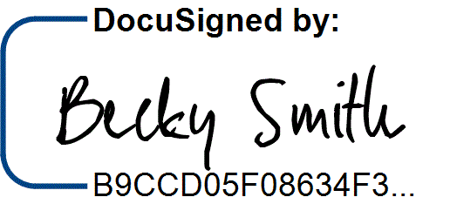
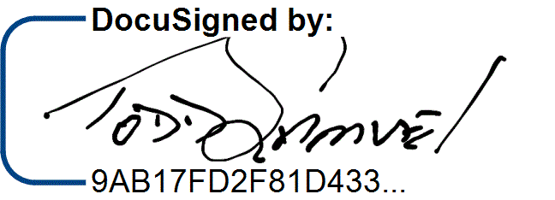
3/2/2021

3/2/2021

Todd Samuel, Board ChairDate

Becky Smith, Office Manager Date

2

